Sri Lanka Institute of Information Technology

Lab Submission

<Worksheet No07>

**<IT24102571>**

**<Gam Acharige W.Y>**

**IT2120 - Probability and Statistics**

B.Sc. (Hons) in Information Technology

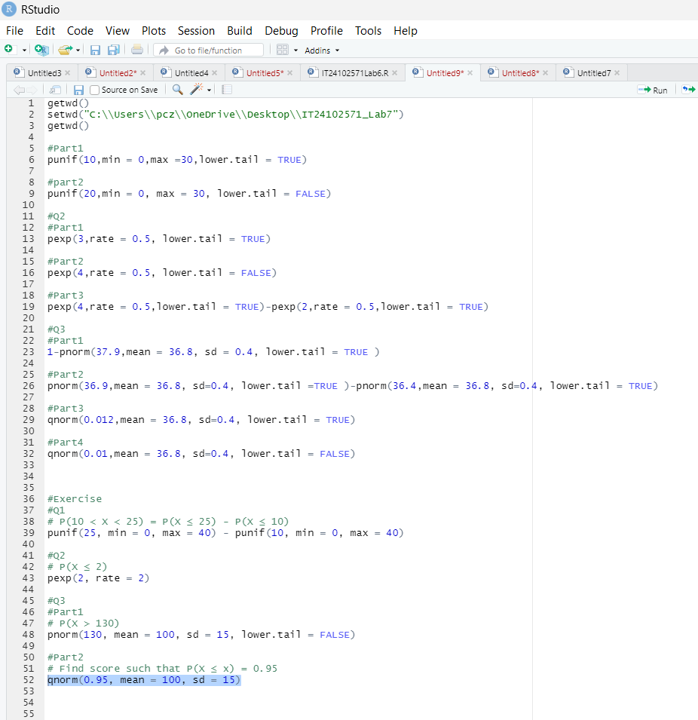



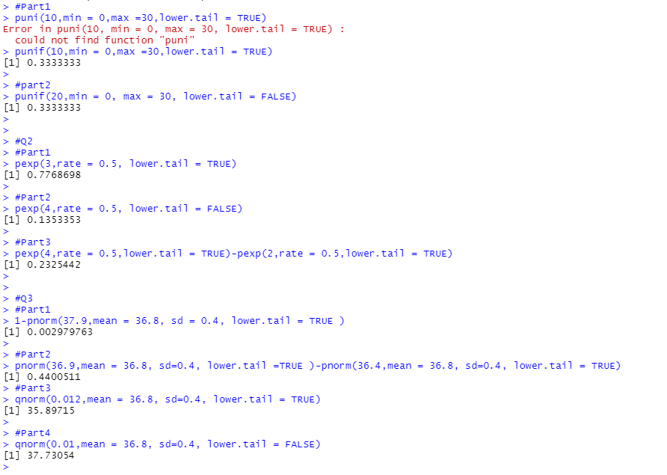

Exercise

Instructions: Create a folder in your desktop with your registration number (Eg: “IT. . . . . . .”). You need to save the R script file and take screenshots of the command prompt with answers and save it in a word document inside the folder. Save both R script file and word document with your registration number (Eg: “IT. . . . . . ..”). After you finish the exercise, zip the folder and upload the zip file to the submission link.

1. A train arrives at a station uniformly between 8:00 a.m. and 8:40 a.m. Let the random variable X represent the number of minutes the train arrives after 8:00 a.m. What is the probability that the train arrives between 8:10 a.m. and 8:25 a.m.?
2. The time (in hours) to complete a software update is exponentially distributed with rate λ = 1 3 . Find the probability that an update will take at most 2 hours
3. Suppose IQ scores are normally distributed with a mean of 100 and a standard deviation of 15.

i. What is the probability that a randomly selected person has an IQ above 130? ii. What IQ score represents the 95th percentile?

